University Explorer

# Group Details

## Group 1

|  |  |
| --- | --- |
| Registration Number | Name |
| 220911470 | Vannela Harshavardhan Reddy |
| 220911440 | Vanshaj Rai |
| 220911536 | Prashast Saxena |

# Project Abstract

University Explorer is a web application designed to help users explore universities, their programs, and rankings worldwide. The application allows users to search for universities based on various criteria such as name, location, and program. Users can view detailed information about each university, including its location, ranking, description, and available programs. Additionally, users can manage their favorite universities by adding or removing them from a favorites list. The application is built using the MERN stack (MongoDB, Express.js, React, Node.js) and utilizes Bootstrap/ReactStrap for styling. The backend handles data retrieval and filtering, while the frontend provides a user-friendly interface for interacting with the application.

# High Level Design

The high-level design of the University Explorer application is structured around the MERN stack, which includes MongoDB, Express.js, React, and Node.js. This architecture ensures a clear separation of concerns, with the frontend and backend components interacting through well-defined APIs. The frontend is responsible for the user interface and user experience, while the backend handles data storage, retrieval, and business logic.

## System Architecture

The system architecture consists of three main components:

### Client (Frontend)

1. The frontend is built using React, a popular JavaScript library for building user interfaces.
2. ReactStrap, a Bootstrap component library for React, is used for styling and responsive design.
3. The frontend communicates with the backend through RESTful APIs using Axios, an HTTP client.
4. React Router is used for client-side routing, enabling smooth navigation between different pages of the application.

### Server (Backend)

1. The backend is built using Node.js and Express.js. Express.js is a web application framework for Node.js that provides a robust set of features for building web and mobile applications.
2. The backend exposes RESTful APIs that the frontend can consume. These APIs handle various operations such as fetching university details, searching for universities, managing user authentication, and handling user favorites.
3. JWT (JSON Web Tokens) is used for secure user authentication and authorization.

### Database

1. MongoDB is used as the database for storing application data.
2. Mongoose, an ODM (Object Data Modeling) library for MongoDB and Node.js, is used to define schemas and interact with the database.
3. The database stores information about universities, programs, users, and user favorites.
4. Aggregation pipelines in MongoDB are used for advanced data querying and filtering, such as searching for universities based on program names.

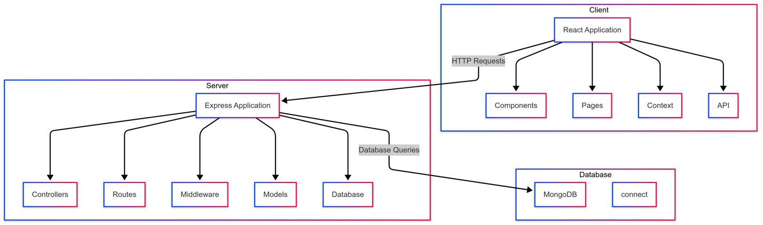

# Components & Concepts Used

* React
  + Explanation: React is a JavaScript library for building user interfaces. It allows developers to create reusable UI components and manage the state of the application efficiently.
  + Use: React is used to build the entire frontend of the application, providing a responsive and interactive user interface. Components like Universities, UniversityDetails, and Favorites are built using React.
* React Router
  + Explanation: React Router is a library for routing in React applications. It enables navigation between different components without reloading the page.
  + Use: React Router is used to handle client-side routing, allowing users to navigate between the home page, universities page, university details page, and favorites page. It uses components like BrowserRouter, Route, and Link.
* Axios
  + Explanation: Axios is a promise-based HTTP client for making requests to a server. It works in both the browser and Node.js environments.
  + Use: Axios is used to make API requests from the frontend to the backend, fetching data such as university details and user favorites. It simplifies the process of handling HTTP requests and responses.
* Context API
  + Explanation: The Context API is a React feature that allows for the creation of global variables that can be passed around the application. It is used for state management.
  + Use: The Context API is used to manage global state, such as user authentication status and user favorites, across the application. It helps in avoiding prop drilling and makes state management more efficient.
* React Hooks
  + Explanation: React Hooks are functions that let you use state and other React features in functional components. Common hooks include useState, useEffect, and useContext.
  + Use: React Hooks are used extensively throughout the application to manage state and side effects. For example, useState is used to manage component state, and useEffect is used to perform side effects like fetching data from the backend.
* Universities Component
  + Explanation: The Universities component is a React component that displays a list of universities based on search criteria.
  + Use: The Universities component fetches data from the backend, handles user input for search and filtering, and displays the results using ReactStrap components like Card, Input, and Button.
* UniversityDetails Component
  + Explanation: The UniversityDetails component is a React component that displays detailed information about a specific university.
  + Use: The UniversityDetails component fetches data from the backend using the university ID from the URL and displays the university's details, including programs and ranking. It uses ReactStrap components like Card, CardBody, and CardTitle.
* Favorites Component
  + Explanation: The Favorites component is a React component that allows users to manage their favorite universities.
  + Use: The Favorites component fetches the user's favorite universities from the backend and displays them. Users can add or remove universities from their favorites list. It uses ReactStrap components like Card and Button.
* Navbar Component
  + Explanation: The Navbar component is a React component that provides navigation links to different sections of the application.
  + Use: The Navbar component includes links to the home page, universities page, favorites page, and user profile. It also displays the user's authentication status. It uses ReactStrap components like Navbar, Nav, and NavItem.
* SearchBar Component
  + Explanation: The SearchBar component is a React component that provides input fields for searching universities based on name, location, and program.
  + Use: The SearchBar component allows users to input search criteria and triggers the search functionality in the Universities component. It uses ReactStrap components like Input and Button.
* Spinner Component
  + Explanation: The Spinner component is a React component that displays a loading spinner while data is being fetched.
  + Use: The Spinner component is used to indicate loading states in various parts of the application, such as when fetching university details or search results. It uses the ReactStrap Spinner component.

# Screenshots & Descriptions

## Home Page

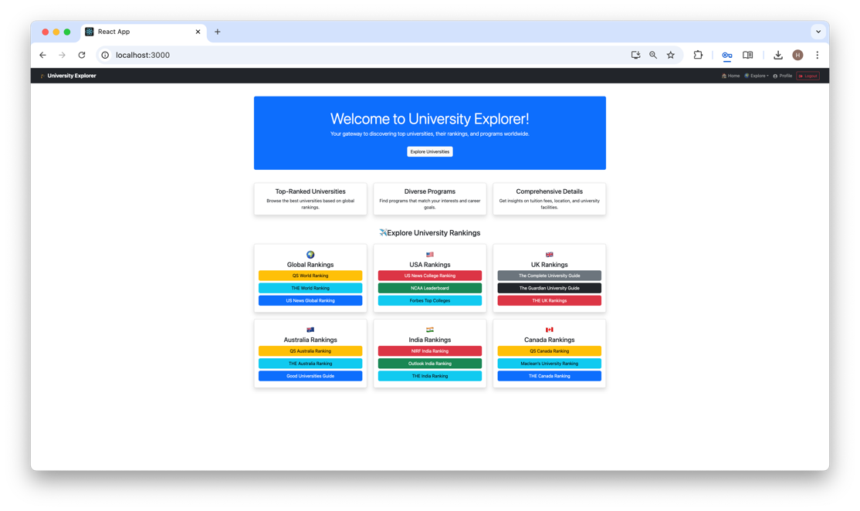

Home Page opens on launching the website. We can click on the links which redirect to those websites. Clicking on Explore Universities redirects to login.

# User Universities

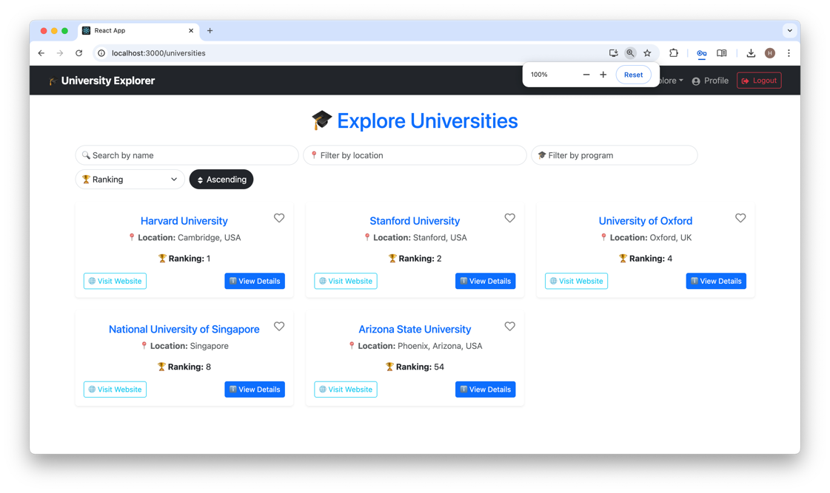

This is the User View of the Universities Page. Sorting by various methods are implemented. Clicking on the buttons takes you to the respective pages.

## User Favorites

User Favourites are displayed. The Remove From Favourites removes the University and updates the Database as well.

## University Details

Specific University Details for each university is a page. It is enabled for both admin type and user type logins.

## Admin Dashboard

This page is enabled only for Admin Logins. The respective links take you to the respective pages. Delete is enabled for all the pages.

## Add Program

Adding Programs for a particular University is enabled only for admin logins. Similar pages for adding universities and users are also present.

## Manage University

Admin only feature. Similar pages for users and programs is also enabled. Delete functionality is working.

# Individual Contribution Details

|  |  |  |
| --- | --- | --- |
| Registration Number | Name | Individual Contirbution |
| 220911470 | Vannela Harshavardhan Reddy | Backend Code and Database Design |
| 220911440 | Vanshaj Rai | Frontend Code and Design |
| 220911536 | Prashast Saxena | Report, Research and Documentation |

# Conclusion & Future Scope

University Explorer is a comprehensive web application designed to help users explore universities and their programs worldwide. By leveraging the MERN stack (MongoDB, Express.js, React, Node.js) and utilizing Bootstrap/ReactStrap for styling, the application provides a robust and scalable solution for managing and displaying university data. The application allows users to search for universities based on various criteria, view detailed information about each university, and manage their favorite universities. The use of modern web development technologies and best practices ensures a responsive and interactive user experience. Overall, University Explorer successfully meets its goal of providing a user-friendly platform for exploring universities and their programs.

## Future Scope

* Enhanced Search Functionality
  + - Description: Improve the search functionality by adding more filters and advanced search options.
    - Implementation: Implement additional filters such as tuition fees, acceptance rates, and campus facilities. Integrate fuzzy search algorithms to handle misspellings and partial matches.
* User Reviews and Ratings:
  + - Description: Allow users to leave reviews and ratings for universities.
    - Implementation: Create a review and rating system where users can submit their feedback on universities. Display average ratings and user reviews on the university details page.
* Recommendation System:
  + - Description: Implement a recommendation system to suggest universities based on user preferences and search history.
    - Implementation: Use machine learning algorithms to analyze user behavior and preferences. Provide personalized university recommendations on the home page and search results page.
* Mobile Application:
  + - Description: Develop a mobile application to provide a seamless experience on mobile devices.
    - Implementation: Use React Native to build a cross-platform mobile application that mirrors the functionality of the web application. Ensure the mobile app is optimized for performance and usability.
* Admin Dashboard Enhancements:
  + - Description: Enhance the admin dashboard with more features and analytics.
    - Implementation: Add features such as user management, detailed analytics on user activity, and university performance metrics. Provide visualizations and reports to help administrators make informed decisions.
* Internationalization and Localization:
  + - Description: Support multiple languages and regional settings to cater to a global audience.
    - Implementation: Implement internationalization (i18n) and localization (l10n) to support multiple languages. Allow users to select their preferred language and regional settings.
* Integration with External APIs:
  + - Description: Integrate with external APIs to provide additional data and services.
    - Implementation: Integrate with APIs such as Google Maps for campus locations, LinkedIn for alumni information, and government databases for accreditation and ranking data.

By focusing on these future enhancements, University Explorer can continue to evolve and provide even more value to its users. These improvements will help the application stay relevant and competitive in the ever-changing landscape of educational technology.